
Submitted by : Spogmai Jan
Roll no : 2430 -0081
Submitted to : mam yusra

Dsa lab 12
Task 01:

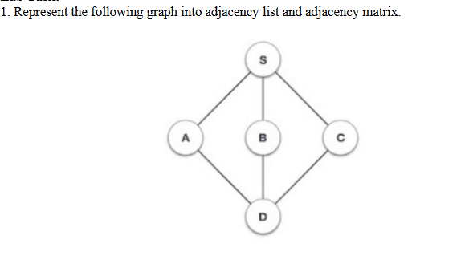
#include <iostream>
#include <vector>
using namespace std;

int main() {

int V = 5;
vector<int> adjList[5];

adjList[0].push_back(1);
adjList[0].push_back(2);
adjList[0].push_back(3);

adjList[1].push_back(0);
adjList[1].push_back(4);

adjList[2].push_back(0);
adjList[2].push_back(4);

adjList[3].push_back(0);
adjList[3].push_back(4);

adjList[4].push_back(1);
adjList[4].push_back(2);
adjList[4].push_back(3);

cout << "Adjacency List:\n";
for(int i = 0; i < V; i++) {
cout << i << " -> ";
for(int j = 0; j < adjList[i].size(); j++) {
cout << adjList[i][j] << " ";
}
cout << endl;
}

int adjMatrix[5][5] = {
{0, 1, 1, 1, 0},
{1, 0, 0, 0, 1},
{1, 0, 0, 0, 1},
{1, 0, 0, 0, 1},
{0, 1, 1, 1, 0}
};

cout << "\nAdjacency Matrix:\n";
for(int i = 0; i < V; i++) {
for(int j = 0; j < V; j++) {
cout << adjMatrix[i][j] << " ";
}
cout << endl;
}

return 0;
}

Output:



